**Starting Out with Visual Basic 2015**

**Chapter 1 Programming Challenges**

**1. Carpet Size**

Step 1:

Purpose: Calculate a room's area in square feet

Input: The length and width of the room

Process: Multiply length by width

Output: The area of the room

Step 2:

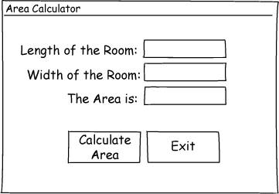

Step 3:

|  |  |
| --- | --- |
| Control Type | Name |
| Form | default |
| Label (for displaying "Length of the Room:") | default |
| Label (for displaying "Width of the Room:") | default |
| Label (for displaying "The Area is:") | default |
| TextBox | txtLength |
| TextBox | txtWidth |
| Label | lblArea |
| Button | btnCalculate |
| Button | btnExit |

Step 4:

|  |  |
| --- | --- |
| Control | Text Property |
| Form | "Area Calculator" |
| Label | "Length of the Room:" |
| Label | "Width of the Room:" |
| Label | "The Area is:" |
| txtLength |  |
| txtWidth |  |
| lblArea |  |
| btnCalculate | "Calculate Area:" |
| btnExit | "Exit" |

Step 5:

|  |  |
| --- | --- |
| Method Name | Description |
| btnCalculate_Click | Multiplies the value stored in the txtLength control's Text property by the value stored in the txtWidth control's Text property. The result is stored in the lblArea control's Text property. |
| btnExit_Click | Ends the application. |

Step 6:

btnCalculate_Click

Flowchart:

Pseudocode:

Start

Multiply the value in txtLength.Text by the value in txtWidth.Text, store result in lblArea.Text.

End

*Multiply the room's length by the room's width and store the result in lblArea.Text.*

btnExit_Click

Flowchart:

Start

End the application.

End

Pseudocode:

End